What does my player need? | 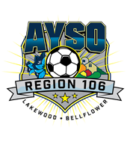

Player’s Equipment and Rules of the Game
Mandatory shin guards and soccer cleats are to be worn during practices and games.
Shin guards must completely be covered by their socks. Make sure to write your player’s names on their soccer ball and water bottle.

Division 6U
-Ball: Size 3
-Players on the field: 5 vs. 5
-Game time: 10-minute halves (5-10 minute halftime)
-No headers
-No goalkeeper

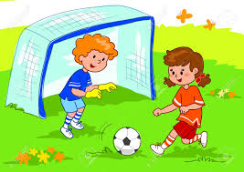 |  |  | Division 8U  -Ball: Size 3  -Players on the field: 7 vs. 7  -Game time: 20-minute halves (5-10 minute halftime)  -Goalkeeper allowed  -No headers
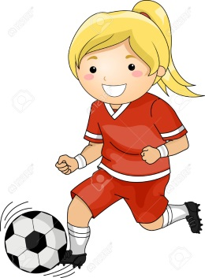 | Division 10U  -Ball: Size 4  -Players on the field: 7 vs. 7  -Game time: 25-minute halves (5-10 minute halftime)  -Goalkeeper allowed  -No headers  -Offside rule
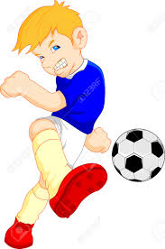 | Division 12U  -Ball: Size 4  -Players on the field: 9 vs. 9  -Game time: 30-minute halves (5-10 minute halftime)  -Goalkeeper allowed  -No headers  -Offside rule
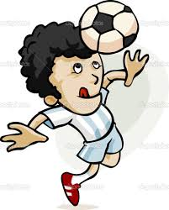 |  | Division 14U  -Ball: Size 5  -Players on the field: 11 vs. 11  -Game time: 35-minute halves (5-10 minute halftime)  -Goalkeeper allowed  -Headers allowed  -Offside rule
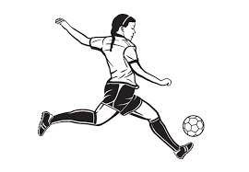 |  | Division 16U  -Ball: Size 5  -Players on the field: 11 vs. 11  -Game time: 40-minute halves (5-10 minute halftime)  -Goalkeeper allowed  -Headers allowed  -Offside rule
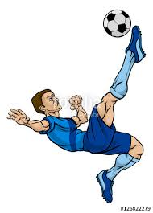 |  | Division 19U  -Ball: Size 5  -Players on the field: 11 vs. 11  -Game time: 45-minute halves (5-10 minute halftime)  -Goalkeeper allowed  -Headers allowed  -Offside rule

----- All Registers Players -----
Coaches will be contacting the players in early August. Please follow our social media and AYSO 106 website www.ayso106.org for more information. Each player will need soccer cleats, shin guards, and an age-appropriate size ball. Uniform jerseys, shorts, and socks will be provided by the region.

If you have any questions, please contact Registrar@ayso106.org or RC@ayso106.org.

THANK YOU and have a great season!
AYSO REGION 106

